Lab 8 Report

Willow Westbrook
Loyola Marymount University
BSAN-6070-02: Intro to Machine Learning

Contact Me
wwestbro@lion.lmu.edu

Introduction
In this lab, I explored time series prediction using an LSTM (Long Short-Term Memory) model, with the goal of forecasting product ratings over time. I used a dataset called product_monthly_panel.csv, focusing specifically on the rating column. My main objective was to determine how well an LSTM could capture temporal patterns in product ratings and provide accurate predictions for future ratings. By analyzing both the model's training behavior and its predictive performance, I hoped to gain insight into the strengths and limitations of using LSTM models for this kind of sequential data.

Methods & Analysis

To prepare the data, I first applied MinMax scaling to normalize the rating values between 0 and 1. I then structured the data into sequences of 7 consecutive ratings to predict the 8th, which is a common technique in time series modeling to help the LSTM learn from past trends. The dataset was split into an 80/20 train-test ratio and passed through a PyTorch DataLoader for batching and shuffling during training. The model itself consisted of a single-layer LSTM with a hidden size of 50 units, followed by a fully connected output layer. I trained the model over 20 epochs using the Adam optimizer and Mean Squared Error (MSE) as the loss function.

The model showed steady improvement in training loss, decreasing from an average loss of 0.0565 in the first epoch to 0.0506 by the final epoch, indicating that the LSTM was learning useful temporal features from the data.
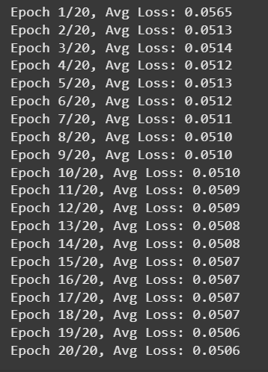

After training, I evaluated the model on the test set and calculated performance metrics. The test MSE was 0.8996 and the RMSE was 0.9485, which suggests that the model made reasonably accurate predictions, with average errors of less than one point on the original rating scale.
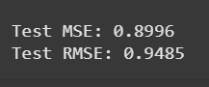
To visually assess the model's performance, I plotted the predicted ratings against the actual ratings for the first 100 test samples. The resulting line plot shows that while the predicted values follow the general trend of the actual ratings, they are noticeably smoother and less volatile. This is typical of LSTM predictions, which often dampen sharp fluctuations due to their memory-based smoothing mechanism. Nevertheless, the model captures several local trends, indicating it has learned some meaningful temporal dependencies.
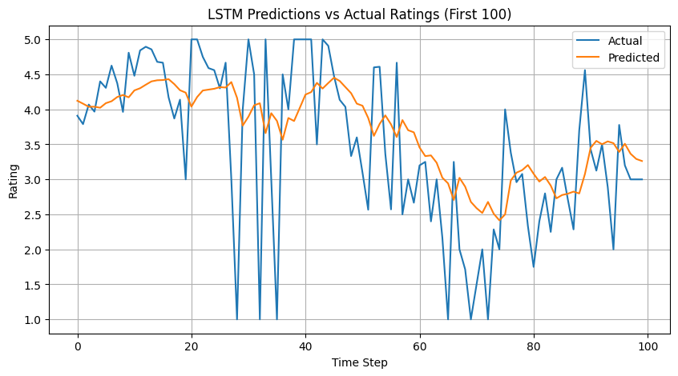

Conclusion & Insights
Overall, this lab highlighted how LSTM models can provide valuable support in business contexts where understanding and anticipating trends is critical. Even though the model didn’t fully capture all the fluctuations in product ratings, it still produced predictions accurate enough to be useful for decision-making. From a managerial perspective, being able to forecast changes in product ratings can help companies identify potential issues before they escalate. For example, a predicted dip in ratings could signal a need for product updates, quality checks, or a shift in customer service strategy. On the marketing side, predicted trends in product sentiment could inform when to run promotions, launch new campaigns, or push user reviews to maintain momentum. These kinds of insights are especially important for products with seasonal cycles, competitive markets, or high customer expectations. The ability to act on anticipated trends—rather than reacting after the fact—can give businesses a strategic edge. This lab also showed me that even a relatively simple LSTM model, trained on just one feature, can still offer actionable insights. That’s promising for business settings where data may be limited or messy, but the need for forward-looking analysis is high. With more development, models like this could be integrated into dashboards or decision support tools used by product teams, analysts, or customer experience managers to drive smarter, more proactive strategies.

